**Task 1: GIT Repository Setup**

**Step 1: Create a GitHub Repository**

1. Go to [GitHub](https://github.com/) and log in (or create an account if you don’t have one).
2. Click on the **"+" (plus icon) → "New Repository"**.
3. Name the repository as **your enrollment number**.
4. Set the repository as **Public** or **Private** (as per instructions from your college).
5. Click **"Create repository"**.

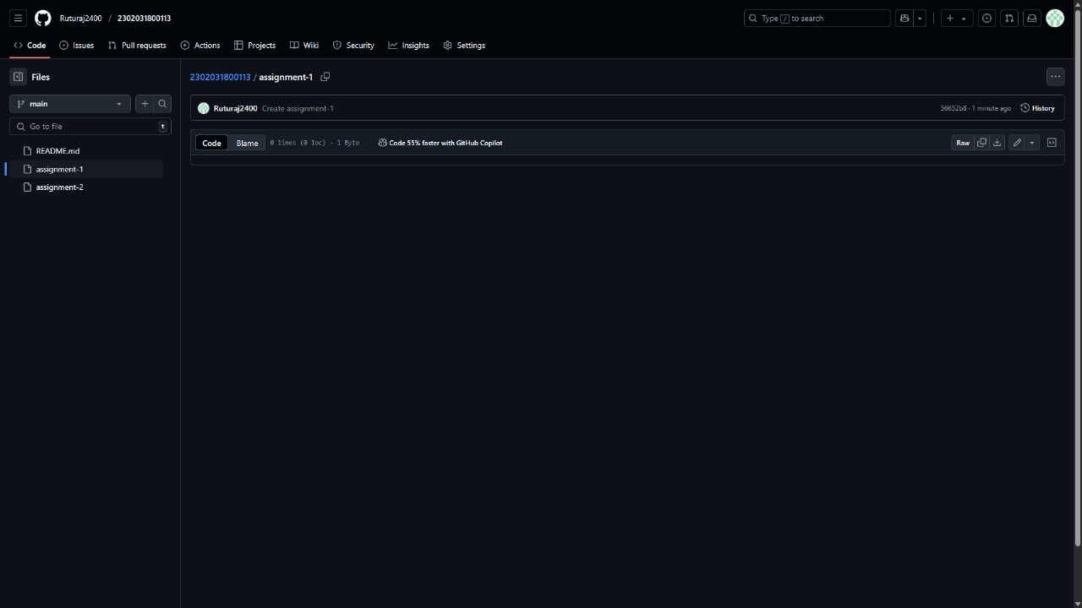

**Step 2: Create Folders in GitHub**

1. Open your repository.
2. Click on **"Add file" → "Create new file"**.
3. In the filename box, type **Assignment_1/** (this creates a folder).
4. In the same way, create another folder named **Assignment_2/**.

